Activity 6.4.5: Challenge Route Summarization (Solution)

Topology Diagram
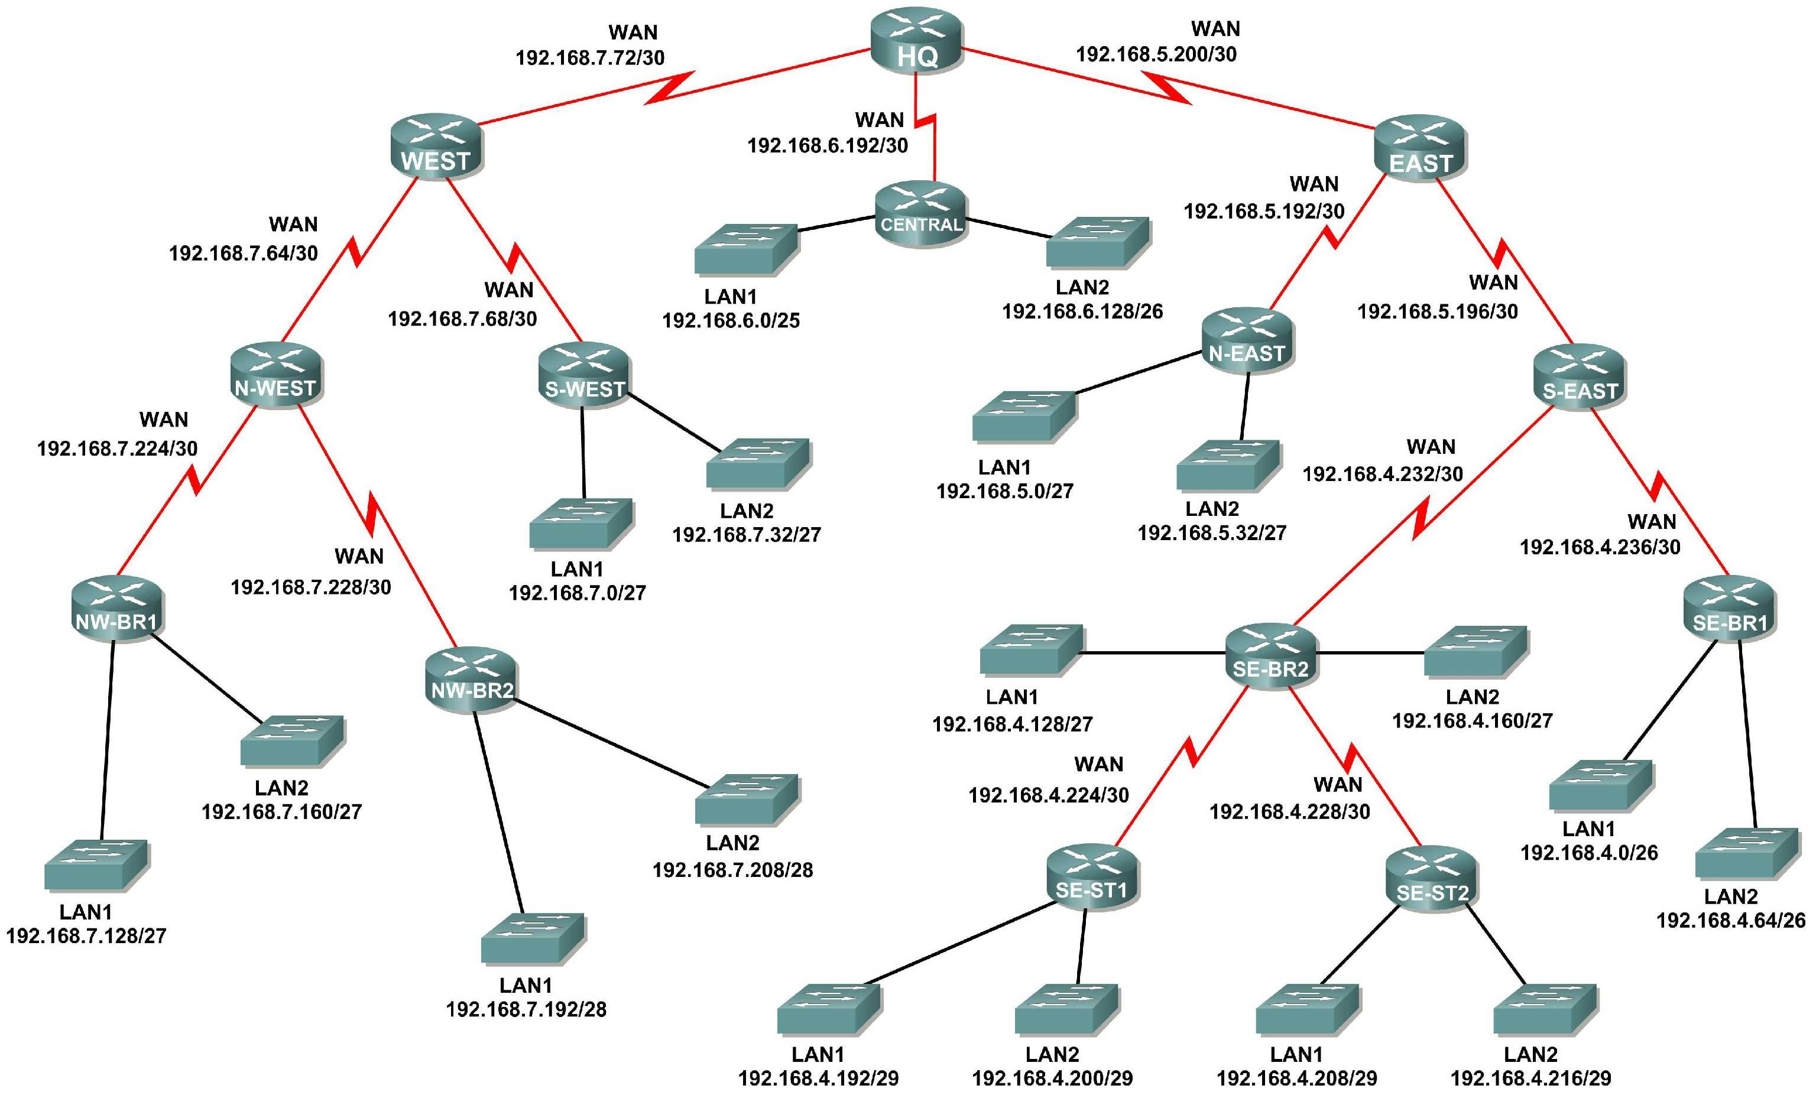

Addressing Table
Subnet | Network Address
S-WEST LAN1 | 192.168.7.0/27
S-WEST LAN2 | 192.168.7.32/27
Link from WEST to N-WEST | 192.168.7.64/30
Link from WEST to S-WEST | 192.168.7.68/30
Link from HQ to WEST | 192.168.7.72/30
NW-BR1 LAN1 | 192.168.7.128/27
NW-BR1 LAN2 | 192.168.7.160/27
NW-BR2 LAN1 | 192.168.7.192/28
NW-BR2 LAN2 | 192.168.7.208/28
Link from N-WEST to NW-BR1 | 192.168.7.224/30
Link from N-WEST to NW-BR2 | 192.168.7.228/30
CENTRAL LAN1 | 192.168.6.0/25
CENTRAL LAN2 | 192.168.6.128/26
Link from HQ to CENTRAL | 192.168.6.192/30
N-EAST LAN1 | 192.168.5.0/27
N-EAST LAN2 | 192.168.5.32/27
Link from EAST to N-EAST | 192.168.5.192/30
Link from EAST to S-EAST | 192.168.5.196/30
Link from HQ to EAST | 192.168.5.200/30
SE-BR1 LAN1 | 192.168.4.0/26
SE-BR1 LAN2 | 192.168.4.64/26
SE-BR2 LAN1 | 192.168.4.128/27
SE-BR2 LAN2 | 192.168.4.160/27
SE-ST1 LAN1 | 192.168.4.192/29
SE-ST1 LAN2 | 192.168.4.200/29
SE-ST2 LAN1 | 192.168.4.208/29
SE-ST2 LAN2 | 192.168.4.216/29
Link from SE-BR2 to SE-ST1 | 192.168.4.224/30
Link from SE-BR2 to SE-ST2 | 192.168.4.228/30
Link from S-EAST to SE-BR2 | 192.168.4.232/30
Link from S-EAST to SE-BR1 | 192.168.4.236/30

Learning Objectives:
- Determine summarized routes that can be used to reduce the size of routing tables.

Scenario
In this activity, you have been given the network shown in the Topology Diagram. The subnetting and address assignments have already been completed for the network segments. Determine summarized routes that can be used to reduce the number of entries in routing tables.
Task 1: Determine the Summary Route for the S-WEST LANs.
Step 1: List the S-WEST LAN1 and LAN2 in binary format.
LAN1 ____________________________________________ 11000000.10101000.00000111.00000000
LAN2 ____________________________________________ 11000000.10101000.00000111.00100000
Step 2: Count the number of left-most matching bits to determine the mask for the summary route.
- How many left-most matching bits are present in the two networks? _______ 26
- What is the subnet mask for the summary route in decimal format? ____________________________________________ 255.255.255.192
Step 3: Copy the matching bits and then add all zeros to determine the summarized network address.
- What is the summary route in binary form? ____________________________________________ 11000000.10101000.00000111.00000000
- What is the network address for the summary route in decimal format? ____________________________________________ 192.168.7.0
Task 2: Determine the Summary Route for the NW-BR1 LANs.
Step 1: List the NW-BR1 LAN1 and LAN2 in binary format.
LAN1 ____________________________________________ 11000000.10101000.00000111.10000000
LAN2 ____________________________________________ 11000000.10101000.00000111.10100000
Step 2: Count the number of left-most matching bits to determine the mask for the summary route.
- How many left-most matching bits are present in the networks? _______ 26
- What is the subnet mask for the summary route in decimal format? ____________________________________________ 255.255.255.192
Step 3: Copy the matching bits and then add all zeros to determine the summarized network address.
- What is the summary route in binary form? ____________________________________________ 11000000.10101000.00000111.10000000
- What is the network address for the summary route in decimal format? ____________________________________________ 192.168.7.128
Task 3: Determine the Summary Route for the NW-BR2 LANs.
Step 1: List the NW-BR2 LAN1 and LAN2 in binary format.
LAN1 ____________________________________________ 11000000.10101000.00000111.11000000
LAN2 ____________________________________________ 11000000.10101000.00000111.11010000
Step 2: Count the number of left-most matching bits to determine the mask for the summary route.
- How many left-most matching bits are present in the networks? _______ 27
- What is the subnet mask for the summary route in decimal format? ____________________________________________ 255.255.255.224
Step 3: Copy the matching bits and then add all zeros to determine the summarized network address.
- What is the summary route in binary form? ____________________________________________ 11000000.10101000.00000111.11000000
- What is the network address for the summary route in decimal format? ____________________________________________ 192.168.7.192
Task 4: Determine the Summary Route for the Northwest Portion of the Network.
Use the networks listed below to determine a summary route for the Northwest portion of the network.
Step 1: List the Northwest network segments in binary format.
NW-BR1 Summary ____________________________________________ 11000000.10101000.00000111.10000000
NW-BR2 Summary ____________________________________________ 11000000.10101000.00000111.11000000
Link from N-WEST to NW-BR1 ____________________________________________ 11000000.10101000.00000111.11100000
Link from N-WEST to NW-BR2 ____________________________________________ 11000000.10101000.00000111.11100100
Step 2: Count the number of left-most matching bits to determine the mask for the summary route.
- How many left-most matching bits are present in the networks? _______ 25
- What is the subnet mask for the summary route in decimal format? ____________________________________________ 255.255.255.128
Step 3: Copy the matching bits and then add all zeros to determine the summarized network address.
- What is the summary route in binary form? ____________________________________________ 11000000.10101000.00000111.10000000
- What is the network address for the summary route in decimal format? ____________________________________________ 192.168.7.128
Task 5: Determine the Summary Route for the West Portion of the Network.
Use the networks listed below to determine a summary route for the West portion of the network.
Step 1: List the West network segments in binary format.
S-WEST Summary ____________________________________________ 11000000.10101000.00000111.00000000
N-WEST Summary ____________________________________________ 11000000.10101000.00000111.10000000
Link from WEST to N-WEST ____________________________________________ 11000000.10101000.00000111.01000000
Link from WEST to S-WEST ____________________________________________ 11000000.10101000.00000111.01000100
Link from HQ to WEST ____________________________________________ 11000000.10101000.00000111.01001000
Step 2: Count the number of left-most matching bits to determine the mask for the summary route.
- How many left-most matching bits are present in the networks? _______ 24
- What is the subnet mask for the summary route in decimal format? ____________________________________________ 255.255.255.0
Step 3: Copy the matching bits and then add all zeros to determine the summarized network address.
- What is the summary route in binary form? ____________________________________________ 11000000.10101000.00000111.00000000
- What is the network address for the summary route in decimal format? ____________________________________________ 192.168.7.0
Task 6: Determine the Summary Route for the Central Portion of the Network.
Use the networks listed below to determine a summary route for the Central portion of the network.
Step 1: List the Central network segments in binary format.
CENTRAL LAN1 ____________________________________________ 11000000.10101000.00000110.00000000
CENTRAL LAN2 ____________________________________________ 11000000.10101000.00000110.10000000
Link from HQ to CENTRAL ____________________________________________ 11000000.10101000.00000110.11000000
Step 2: Count the number of left-most matching bits to determine the mask for the summary route.
- How many left-most matching bits are present in the networks? _______ 24
- What is the subnet mask for the summary route in decimal format? ____________________________________________ 255.255.255.0
Step 3: Copy the matching bits and then add all zeros to determine the summarized network address.
- What is the summary route in binary form? ____________________________________________ 11000000.10101000.00000110.00000000
- What is the network address for the summary route in decimal format? ____________________________________________ 192.168.6.0
Task 7: Determine the Summary Route for the N-EAST LANs.
Step 1: List the N-EAST LAN1 and LAN2 in binary format.
LAN1 ____________________________________________ 11000000.10101000.00000101.00000000
LAN2 ____________________________________________ 11000000.10101000.00000101.00100000
Step 2: Count the number of left-most matching bits to determine the mask for the summary route.
- How many left-most matching bits are present in the networks? _______ 26
- What is the subnet mask for the summary route in decimal format? ____________________________________________ 255.255.255.192
Step 3: Copy the matching bits and then add all zeros to determine the summarized network address.
- What is the summary route in binary form? ____________________________________________ 11000000.10101000.00000101.00000000
- What is the network address for the summary route in decimal format? ____________________________________________ 192.168.5.0
Task 8: Determine the Summary Route for the SE-BR1 LANs.
Step 1: List the SE-BR1 LAN1 and LAN2 in binary format.
LAN1 ____________________________________________ 11000000.10101000.00000100.00000000
LAN2 ____________________________________________ 11000000.10101000.00000100.01000000
Step 2: Count the number of left-most matching bits to determine the mask for the summary route.
- How many left-most matching bits are present in the networks? _______ 25
- What is the subnet mask for the summary route in decimal format? ____________________________________________ 255.255.255.128
Step 3: Copy the matching bits and then add all zeros to determine the summarized network address.
- What is the summary route in binary form? ____________________________________________ 11000000.10101000.00000100.00000000
- What is the network address for the summary route in decimal format? ____________________________________________ 192.168.4.0
Task 9: Determine the Summary Route for the SE-BR2 LANs.
Step 1: List the SE-BR2 LAN1 and LAN2 in binary format.
LAN1 ____________________________________________ 11000000.10101000.00000100.10000000
LAN2 ____________________________________________ 11000000.10101000.00000100.10100000
Step 2: Count the number of left-most matching bits to determine the mask for the summary route.
- How many left-most matching bits are present in the networks? _______ 26
- What is the subnet mask for the summary route in decimal format? ____________________________________________ 255.255.255.192
Step 3: Copy the matching bits and then add all zeros to determine the summarized network address.
- What is the summary route in binary form? ____________________________________________ 11000000.10101000.00000100.10000000
- What is the network address for the summary route in decimal format? ____________________________________________ 192.168.4.128
Task 10: Determine the Summary Route for the SE-ST1 LANs.
Step 1: List the SE-ST1 LAN1 and LAN2 in binary format.
LAN1 ____________________________________________ 11000000.10101000.00000100.11000000
LAN2 ____________________________________________ 11000000.10101000.00000100.11001000
Step 2: Count the number of left-most matching bits to determine the mask for the summary route.
- How many left-most matching bits are present in the networks? _______ 28
- What is the subnet mask for the summary route in decimal format? ____________________________________________ 255.255.255.240
Step 3: Copy the matching bits and then add all zeros to determine the summarized network address.
- What is the summary route in binary form? ____________________________________________ 11000000.10101000.00000100.11000000
- What is the network address for the summary route in decimal format? ____________________________________________ 192.168.4.192
Task 11: Determine the Summary Route for the SE-ST2 LANs.
Step 1: List the SE-ST2 LAN1 and LAN2 in binary format.
LAN1 ____________________________________________ 11000000.10101000.00000100.11010000
LAN2 ____________________________________________ 11000000.10101000.00000100.11011000
Step 2: Count the number of left-most matching bits to determine the mask for the summary route.
- How many left-most matching bits are present in the networks? _______ 28
- What is the subnet mask for the summary route in decimal format? ____________________________________________ 255.255.255.240
Step 3: Copy the matching bits and then add all zeros to determine the summarized network address.
- What is the summary route in binary form? ____________________________________________ 11000000.10101000.00000100.11010000
- What is the network address for the summary route in decimal format? ____________________________________________ 192.168.4.208
Task 12: Determine the Summary Route for the Southeast Portion of the Network.
Use the networks listed below to determine a summary route for the Southeast portion of the network.
Step 1: List the Southeast network segments in binary format.
SE-BR1 Summary ____________________________________________ 11000000.10101000.00000100.00000000
SE-BR2 Summary ____________________________________________ 11000000.10101000.00000100.10000000
SE-ST1 Summary ____________________________________________ 11000000.10101000.00000100.11000000
SE-ST2 Summary ____________________________________________ 11000000.10101000.00000100.11010000
Link from SE-BR2 to Satellite1 ____________________________________________ 11000000.10101000.00000100.11100000
Link from SE-BR2 to Satellite2 ____________________________________________ 11000000.10101000.00000100.11100100
Link from S-EAST to SE-BR1 ____________________________________________ 11000000.10101000.00000100.11101100
Link from S-EAST to SE-BR2 ____________________________________________ 11000000.10101000.00000100.11101000
Step 2: Count the number of left-most matching bits to determine the mask for the summary route.
- How many left-most matching bits are present in the networks? _______ 24
- What is the subnet mask for the summary route in decimal format? ____________________________________________ 255.255.255.0
Step 3: Copy the matching bits and then add all zeros to determine the summarized network address.
- What is the summary route in binary form? ____________________________________________ 11000000.10101000.00000100.00000000
- What is the network address for the summary route in decimal format? ____________________________________________ 192.168.4.0
Task 13: Determine the Summary Route for the East Portion of the Network.
Use the networks listed below to determine a summary route for the East portion of the network.
Step 1: List the East network segments in binary format.
S-EAST Summary ____________________________________________ 11000000.10101000.00000100.00000000
N-EAST Summary ____________________________________________ 11000000.10101000.00000101.00000000
Link from EAST to N-EAST ____________________________________________ 11000000.10101000.00000101.11000000
Link from EAST to S-EAST ____________________________________________ 11000000.10101000.00000101.11000100
Link from HQ to EAST ____________________________________________ 11000000.10101000.00000101.11001000
Step 2: Count the number of left-most matching bits to determine the mask for the summary route.
- How many left-most matching bits are present in the networks? _______ 23
- What is the subnet mask for the summary route in decimal format? ____________________________________________ 255.255.254.0
Step 3: Copy the matching bits and then add all zeros to determine the summarized network address.
- What is the summary route in binary form? ____________________________________________ 11000000.10101000.00000100.00000000
- What is the network address for the summary route in decimal format? ____________________________________________ 192.168.4.0
Task 14: Determine the Summary Route for the Entire Network.
Use the networks listed below to determine a summary route for the entire network.
Step 1: List the East, West, and Central summary routes in binary format.
EAST Summary ____________________________________________ 11000000.10101000.00000100.00000000
WEST Summary ____________________________________________ 11000000.10101000.00000111.00000000
CENTRAL Summary ____________________________________________ 11000000.10101000.00000110.00000000
Step 2: Count the number of left-most matching bits to determine the mask for the summary route.
- How many left-most matching bits are present in the networks? _______ 22
- What is the subnet mask for the summary route in decimal format? ____________________________________________ 255.255.252.0
Step 3: Copy the matching bits and then add all zeros to determine the summarized network address.
- What is the summary route in binary form? ____________________________________________ 11000000.10101000.00000100.00000000
- What is the network address for the summary route in decimal format? ____________________________________________ 192.168.4.0

